November 3, 2021

**Employee Spotlight – Meet Frank Crisostomo**

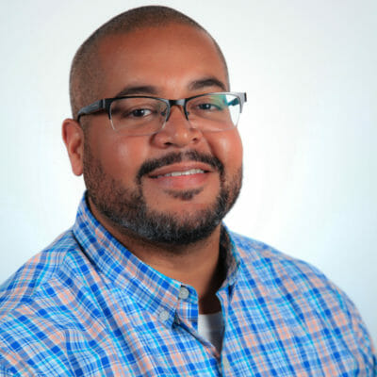

A great teammate, a great mentor, a kind presence, a helping hand, a positive person – these are the characteristics we strive for at CloudFit and Site Reliability Engineer Frank Crisostomo embodies them well. As a leader on our “Managed Client Experience” service, Frank consistently leads his team to great results, cultivates new employees in our way of operation**s**, and exudes a calming presence during tense times. Check out our interview below to learn more about Frank!

**What does your career background look like?**

I have been in IT for almost 15 years. I worked in several roles including, application support analyst, desktop support analyst, project team lead, systems engineer, premier field engineer, and site reliability engineer. In the last five years, I had the opportunity to become a subject matter expert in Microsoft Azure, 365, and Endpoint Manager. Most recently, my focus has been on implementing automation to solve various challenges including, scalability and security.

**What is your role at CloudFit Software?**

Senior Site Reliability Engineer

**What’s the best thing about your job?**

The best thing about my job is helping our customers and my teammates achieve results.

**What surprised you most about working for CloudFit?**

Since my first interview with CloudFit, I knew that things were different here. I understood that they cared about people and believed in their mission to make a difference. CloudFit fosters a culture that encourages growth, collaboration, and servant leadership. The most surprising is how the culture is still intact considering the growth of the company.

**What would you say is CloudFit’s biggest strength?**

It’s people without any doubt. Some of the brightest people in the industry and some of the most caring people work here. There is no shortage of people willing to help you achieve your goals at CloudFit.

**What’s been one of your proudest moments working at CloudFit?**

Most recently, I had the opportunity to help some of my colleagues earn a Microsoft Azure certification. I always feel good about helping others.

**What inspires you?**

Becoming knowledgeable in technologies that interest me, sharing that knowledge with others, and inspiring them to do the same. I have been fortunate to have people in my career do the same for me.

**What are five words (or a short sentence) of advice for others in your profession?**

* Integrity
* Credibility
* Learn
* Teach
* Inspire

**What do you like to do when you’re not at the office?**

Spending time with my family and our three puppies.

Filed Under: [Uncategorized](https://www.cloudfitsoftware.com/category/uncategorized/)